Respected sir  
  
As you are aware there is our internship season going on and we have to go to main campus for giving the online assessments so we need to miss our classes in order to give their tests. I request you to verify and award/compensate the corresponding attendances:

**1)3 August:**

**American Express Online Assessment:**

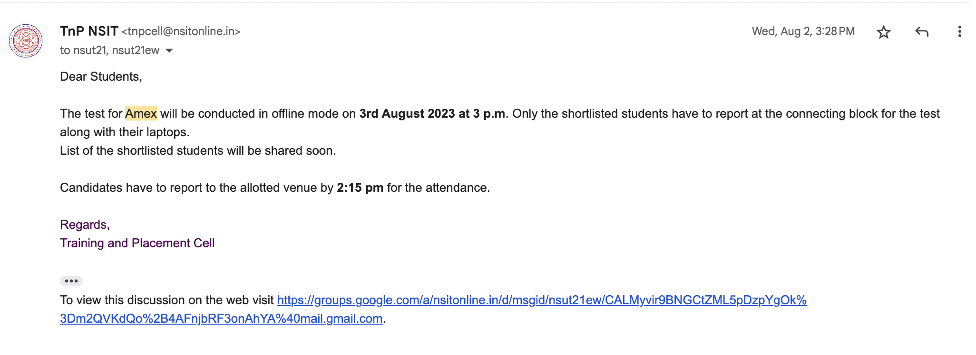

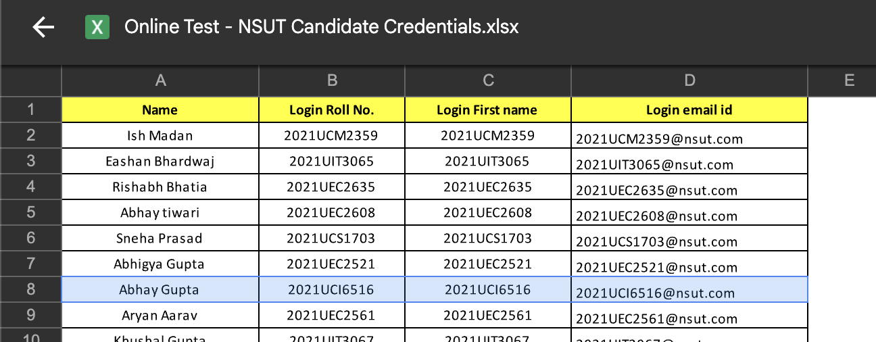

Classes held:

11-12 ACN

12-2 G1 EMBEDDED SYSTEMS LAB

G2 ACN LAB

2-4 g1 data science lab

g2 embedded systems lab

4-5 embedded systems theory

**2)8 August**

**American Express Interview:**

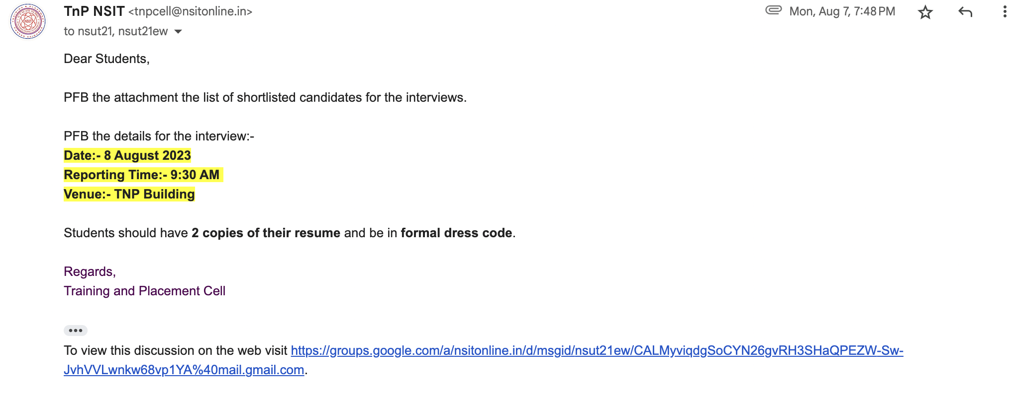

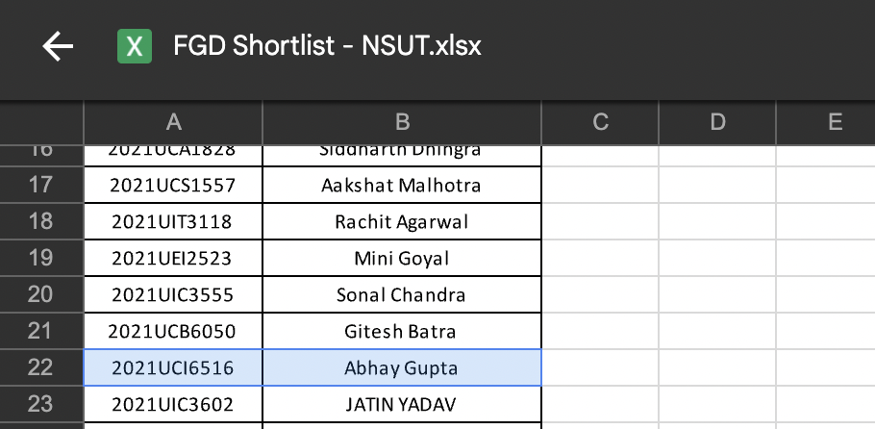

Classes held:

10-11 Data Science

11-12 AIML

1-2 ACN

**2)17 August**

**Triology Online Assessment**

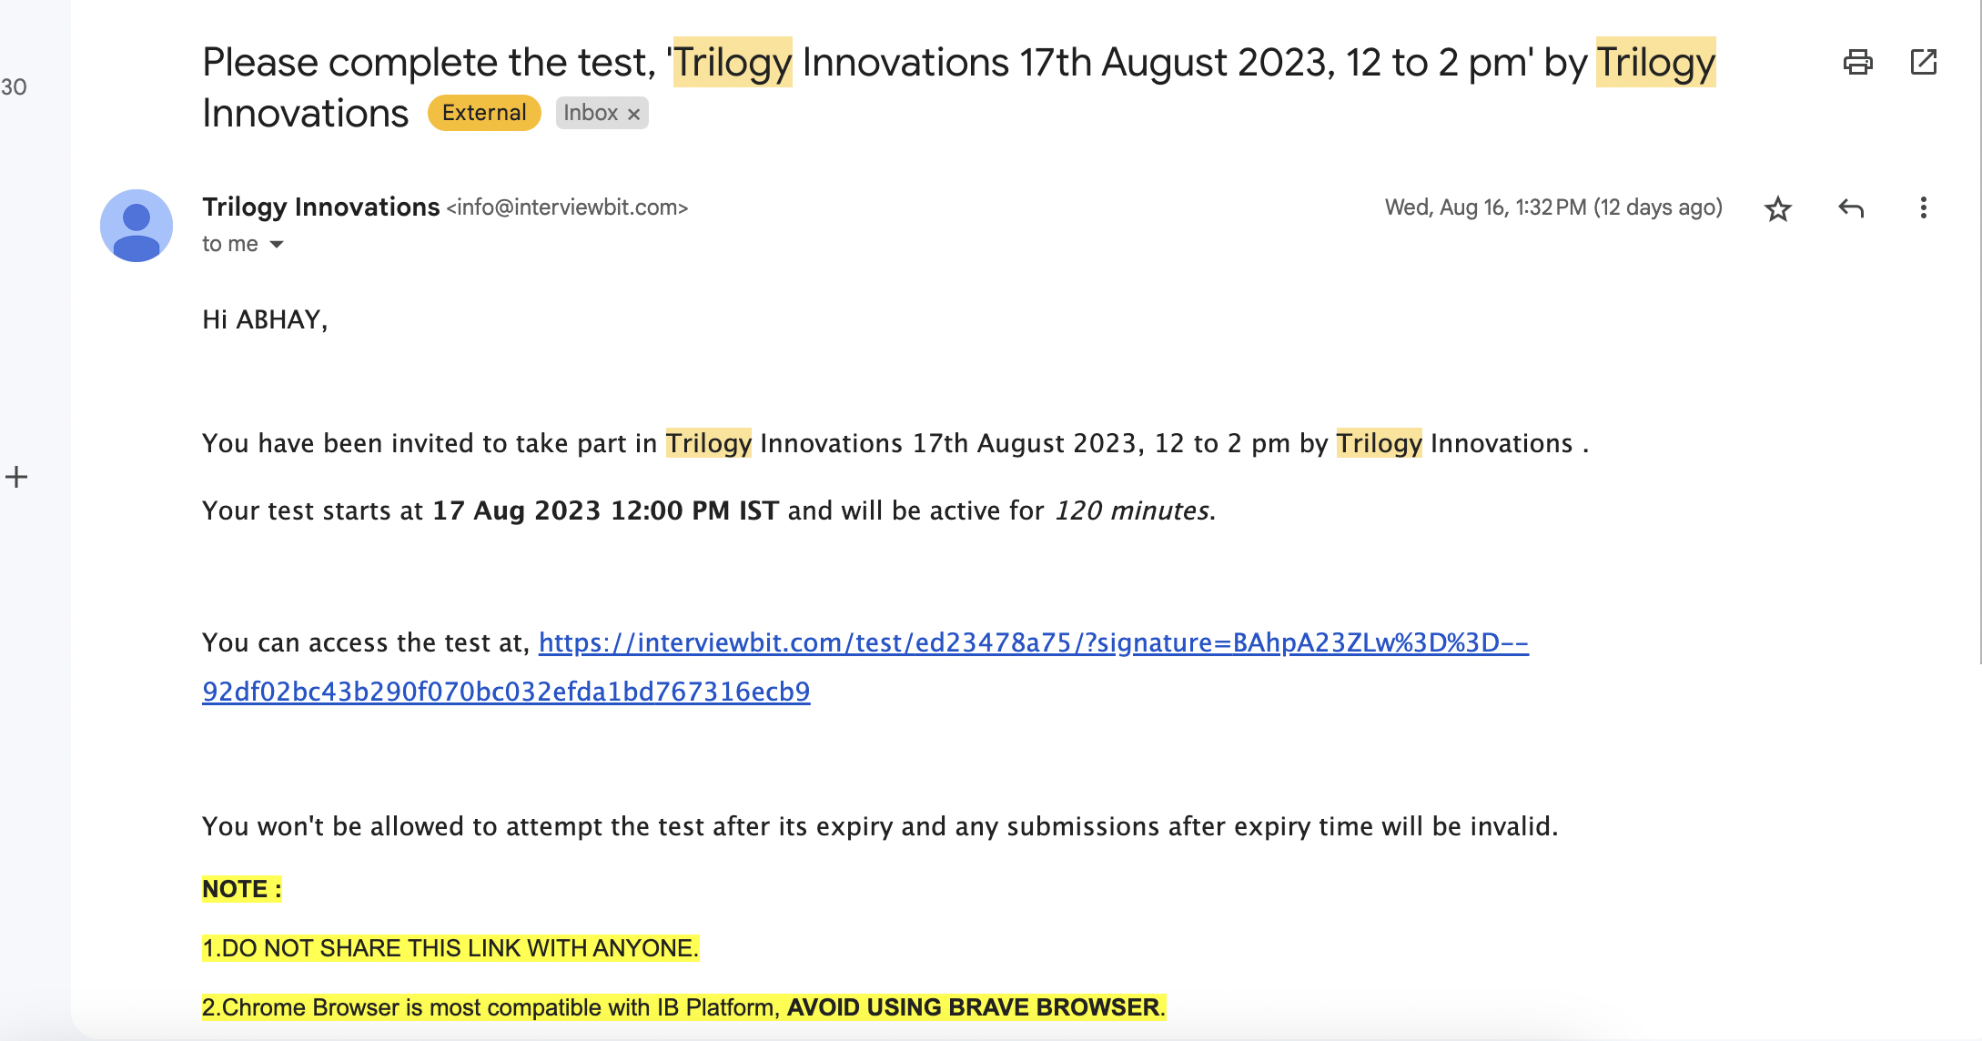

Classes held:

10-11 Data science

11-12 AI-ML

1-2 ACN(theory)

2-4 ACN LAB (G1+G2) F303/304

**2)18 August:**

**VISA Online Assessment**

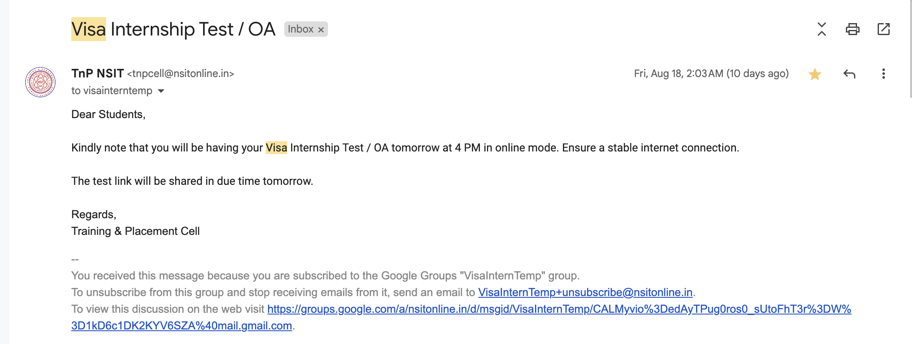

Classes held:

CLOUD COMPUTING CLASS 11-12

E307 ACN class

Verified By:

Prof. Vishal Bhatnagar

TPO (NSUT EAST)